Scholarship and Application information for

Unleash The Maui Maori LEadership programme 2020
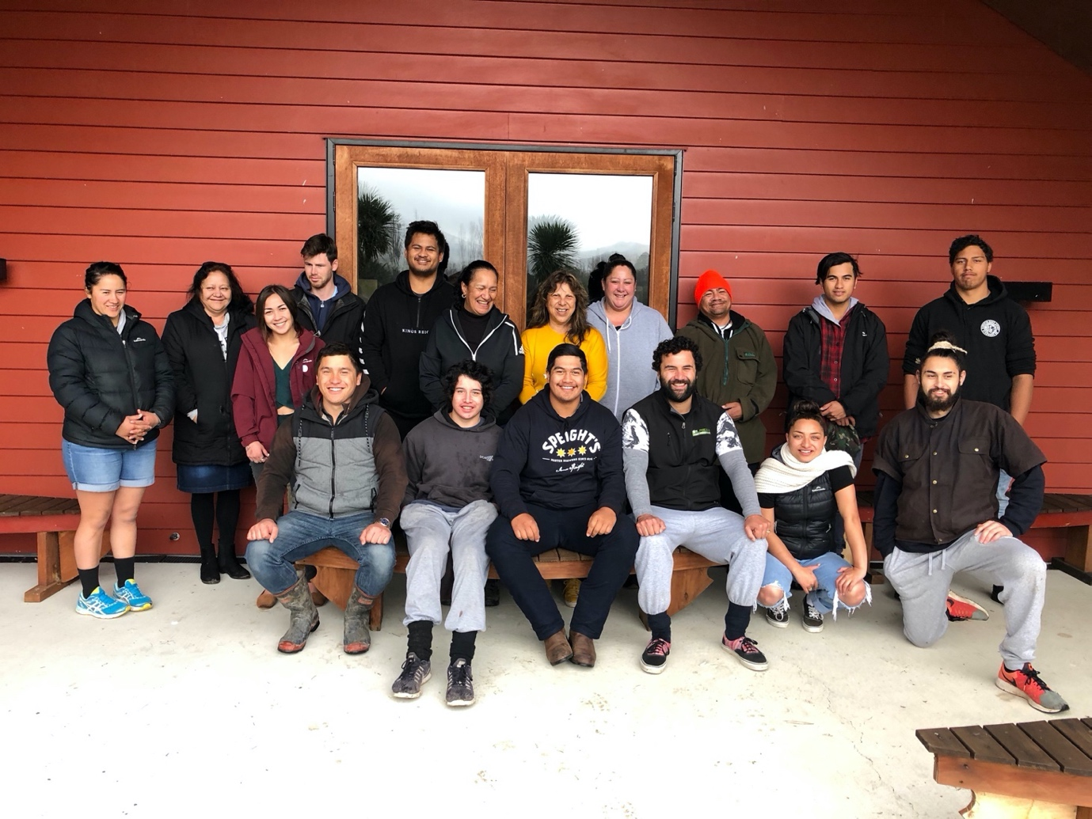

BACKGROUND
Unleash the Maui Agricultural Leadership Program is the signature training program of the Red Meat Profit Partnership and Whenua Kura Trust. This multi-disciplinary national program brings together promising leaders from the Aotearoa agriculture, natural resources management and rural community sectors. By combining strong personal development, sector leadership content with exposure to organisations, agricultural operations and community networks, participants develop their path toward becoming the innovative problem-solvers and leaders that are so needed in the sector to combine sustainability, Matauranga Maori and the opportunities offered through the Primary Sector.

RECRUITMENT INFORMATION
Applicant Eligibility
The programme seeks applicants who can demonstrate a serious commitment to strengthening Maori agriculture in Aotearoa through their work and/or volunteer activities. Priority is given to applicants who work directly in agriculture (e.g., livestock, forestry, agriculture) or agriculture industry support endeavors (e.g., processing, handling, shipping, and delivering products to the consumer, or financing and management). Other primary industry workers who work closely with agricultural communities, as well as those involved in rural community development, are also invited to apply.
All applicants must be Maori. Applicants must have approval from their employer to take the required time to participate in the programme.

Applicant Commitment
Every applicant is expected to make the following commitments if she or he is selected for Unleash Maui:
- To attend all wananga April 2-5, June 10-13, September 24-25
- To complete a set number of sector and industry promotion activities for local rangatahi
- To continue leadership and responsibility within the industry or community, during and post program
- To participate in follow-up assessments and post-programme leadership activities
- To be actively committed to the continuance of the Unleash Maui, including future assistance with fundraising, mentoring future class members, and other initiatives

Application and Selection Process, Criteria and Policies
Applicants are required to submit an Application Form, an Employer’s Commitment Form (if applicable).
The Selection Committee, comprised of program staff, RMPP staff and Whenua Kura board members, and alumni, will review applications and select those who will be interviewed. Applicants are reviewed based upon the following criteria:
- Interest and desire to participate in the Unleash Maui
- Demonstrated leadership qualities as evidenced by community, industry or government organizational activities and positions of responsibility
- Commitment to strengthening agriculture in Aotearoa and creating sustainable communities
- Commitment to learning and personal growth
- Written, verbal, and non-verbal communication skills
- Ability to make time and travel commitment
The Selection Committee will also consider and apply the following additional policies:
- Each cohorts will reflect a reasonable representation of geographical locations as well as business, government, and non-profit organizations.
- All applicants must be willing to sign a general release of liability form and provide relevant medical information to assist with health and safety

Recruitment and Selection Timeline
- Recruitment communications began in 2019
- Applications for 2020 will be available in January of 2020. Application deadline will be 20 February
- Informational zoom or conference calls with programme staff can be available prior to the application deadline.
- Selection timeline is to be determined.

Tuition
Over the course of 9 months, the value of the Unleash Maui is over $10,000 per participant. Much of this is subsidized by funding from RMPP, Whenua Kura and other training partners. The costs support participant travel costs (airfare, shared lodging, and ground transportation) for three wananga.

Unleash Maui – Learning Objectives:
- Quality career and sector pathways will be identified and understood
- Te reo, tikanga, whanaungatanga will be affirmed
- identify key issues, opportunties and challenges in the sector
- experience some of the emerging innovation and technology that is disrupting the sector
- develop personal 1-3 year goal setting plans
- understand a range of communications preferences and develop skills to communicate effectively with others
- develop relationships and networks to support industry success
- identify and participate in a collaborative project of benefit to the sector
- introduction to governance of Maori organisations

COHORTS
The cohort for 2020 will include up to 14 participants from small, medium and large agriculture-related training programmes and farms, farming related businesses, as well as representation from other iwi organisations that connect directly to agriculture and natural resources. Having a diverse cohort is central to developing effective resources and relationships that will last long beyond the program’s conclusion.
Participants must make a serious time commitment to Unleash Maui. This time commitment is the most significant challenge, but the rewards are immeasurable. Alumni are available to share their experiences, skills and knowledge with potential applicants.

UNLEASH MAUI TRAINING TEAM
The training team for Unleash the Maui includes those with expertise in Matauranga Maori, the sector and Maori leadership and governance.
For further information please contact project manager, lead facilitator - Kym Hamilton kym.hamilton001@gmail.com or 0272545821

Current tauira see a need for a young Maori voice into the sector and to combine with Maori in other parts of the primary sector including forestry. They would like to see the programme continue and grow and to mentor and support others into primary careers. They are keen for matauranga Maori, industry relationships, support for ongoing training and development and to give to others.
Through Unleash the Maui, participants develop the knowledge, relationships, tools and skills that will enable them to be more successful in their work and other sector and community endeavors. Unleash Maui trains individuals who have already demonstrated a commitment to lead in their sector and community activities. This is not specifically an agricultural or farm production training program.
The primary sector, and beef and sheep farming is a vital sector of the Aotearoa economy. In these times where divergent views of farming and agriculture tend to pull the sector apart, it is more important than ever to work together because the economic and cultural vitality of agriculture and rural communities has significant impact throughout our entire society. That Maori agricultural economic and social contributions and Iwi investment has been significant in the sector is core to this proposal.
If we as a community maintain that a healthy, thriving, sustainable agriculture sector is an important part of our development as a nation, we must continue to support those who will help get us there. We need strong, effective voices helping to show the way and combining Matauranga Maori and cultural values that offer solutions to many of the challenges facing the sector.

CURRICULUM
Unleash Maui curriculum includes training in facilitation and group process, while highlighting the importance of leadership, collaboration, mediation, systems thinking and more. Educational site visits to farms, agri-tech, aquaculture and ag-forestry businesses, nurseries, watershed protection areas, cultural projects and other rural community endeavors are an essential component of the program. Through visits to MPI and other agencies participants gain first-hand exposure to government policymaking and implementation. Additionally, participants complete a collaborative Project that examines an agricultural issue and enables Maori leadership perspectives to enter the public domain.
Unleash participants will attend wananga around the country and will also take part in planning a national event. The program spans a period of 9 months. The wananga, typically 3 days each, will introduce content areas integral to sustainable farming in Aotearoa (e.g., water, land, labor, markets and sustainability practices). After wananga 1, participants will play a role in wananga planning so some aspects of learning can be designed to meet the cohort specific interests. Participation in Field days complements the local seminars by providing participants with a broader perspective. During the wananga the cohort will be exposed to agricultural and rural community systems and the Federation of Maori Authorities. This exposure will highlight points of commonality as well as unique perspectives of Maori and Maori business.

